HEP-18-1167
S1. Scoring method for liver tissue sections after H&E and immunohistochemistry. All slides were imaged using a Leica DMR microscope (Leica Biosystems, Newcastle, UK) equipped with a Leica DFC300 FX camera (Leica Biosystems, Newcastle, UK). Five high power fields were randomly selected for each case from the lobular region and the number of MPO positive cells was counted in each field. H&E stained slides were scored using a routine system with several changes, for neutrophil clustering (0 = none; 1 = occasional, found after very scrupulous search at high magnification (400×); 2 = scattered, easily seen at 100× magnification; 3 = scattered in most lobules; 4 many neutrophil clusters in close proximity on the verge of confluence; 5 = dense confluent sheets), apoptosis or necrosis (0 = absent; 1 = 1-2 apoptotic bodies per 200× magnification field (highest number per field recorded); 3 = focal hepatocyte necrosis, 1-2 foci per 200× magnification field (highest number per field recorded); 4 = 3 or more foci per 200× magnification field (highest number per field recorded); 5 = focal confluent hepatocellular necrosis; 6 = multiple foci of confluent necrosis; 7 = areas of necrotic parenchyma more extensive than the viable parenchyma in the sample examined; 8 = a limited amount of viable parenchyma is identified), mitosis (number of mitoses in 10 HPF at 400× magnification), canalicular cholestasis (0 = none; 1 = mild; 2 = moderate; 3 = severe), ductular cholestasis (0 = none; 1 = mild; 2 = moderate; 3 = severe), and signs of cholangitis (0 = absent; 1 = present). Steatosis was assessed as large droplet steatosis (a single large steatotic vacuole pushing the hepatocyte nucleus to the periphery), and small droplet steatosis (one or more small cytoplasmic vacuoles mostly associated with a centrally placed nucleus) as two separate yet identical scores (0 = none; 1 = < 26%; 2 = 26-50%; 3 = 51-75%; 4 = > 75%). Large droplet steatosis was scored first. The small droplet steatosis was assessed afterwards, this second score representing the percentage of hepatocytes without large droplet steatosis. Stains were assessed by a Liver Histopathology Fellow (O.P.) and a Histopathologist (A.Q.) who were blinded to the clinical data. All counts were performed using the ImageJ software (Bethesda, Maryland, USA).

S2: Full list of canonical GSEA pathways, a total of 123 pathways, that were considered significantly down-regulated in NMP compared to CS in the pre-reperfusion stage, based on the cut-off value of <25% false discovery rate (FDR). NES: Normalised enrichment score.

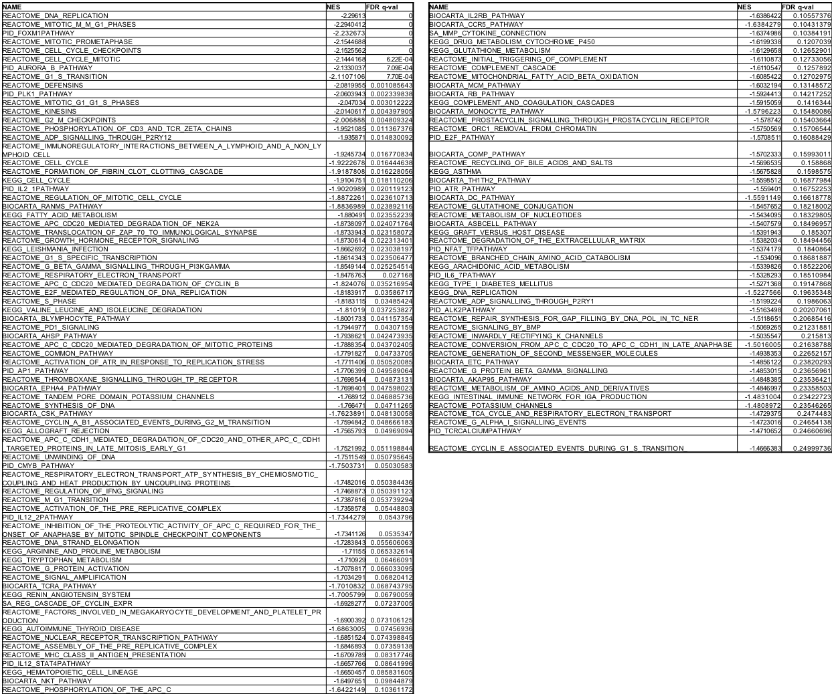


S3: Full list of canonical GSEA pathways, a total of 74 pathways, that were considered significantly down-regulated in NMP compared to CS in the post-reperfusion stage, based on the cut-off value of <25% false discovery rate (FDR). NES: Normalised enrichment score

